**Stress on Cortical Bone and cancellous bone**

Maximum minimum principal stresses on cortical and cancellous bone

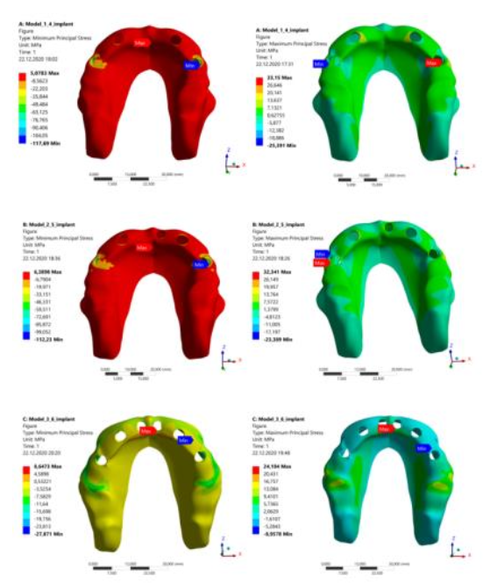

**Stress in the Right and left zygomatic Zygomatic Bone**

Maximum minimum principal stresses on zygomatic bone

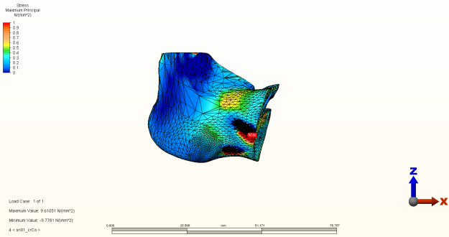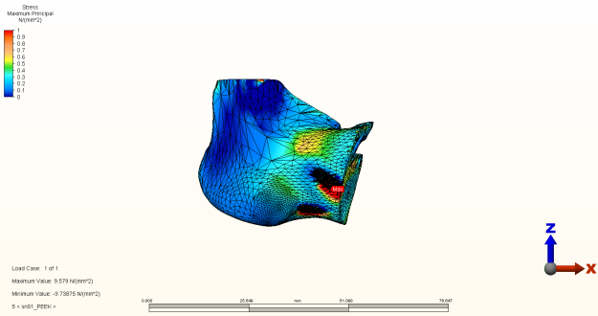

**Stress on Implants**

Von misses stress values

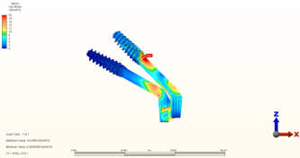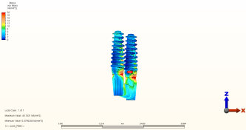

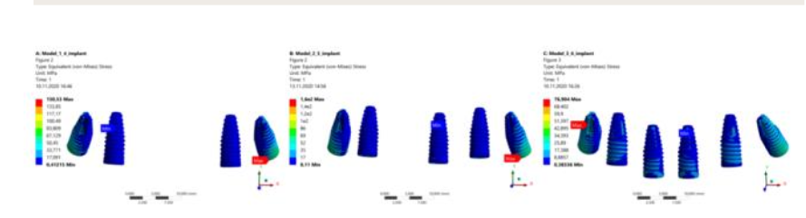

**Stress in substructure (titanium and graphen bar)**

Von misses stress values üst yapı ile birleşim kısmını görecek şekilde kesitler alınsa daha güzel olur.

Stress on abutments (for BLX &BLT& Zygomatic)

Von misses stress values

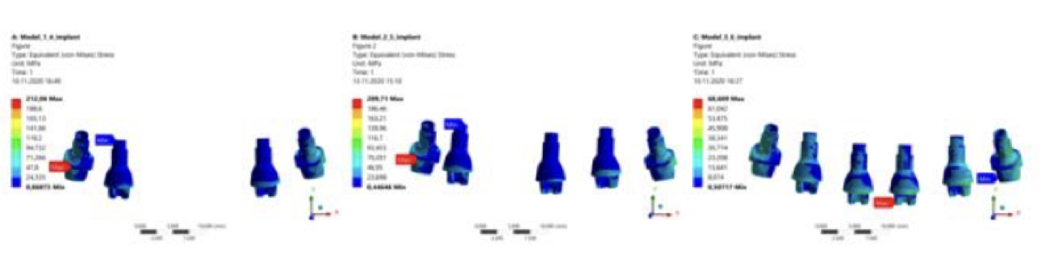

**Stress on abutment screws** (for BLX &BLT& Zygomatic)

Von misses stress values

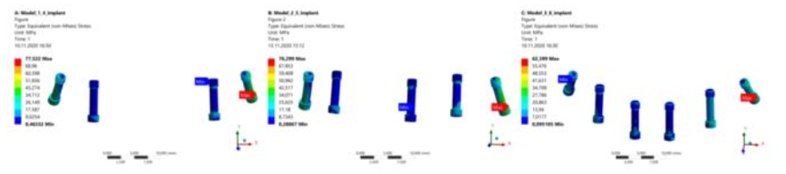

**Stress on prosthesis**

Von misses stress values